Tim Sweetland

EE3600 Lab 3 Report

Circuit Controller Design

# Objective

This lab poses a design problem which needs understanding of PID (proportional/integrator/differentiator) controllers as well as basic circuitry in combination with problem solving skills to learn. While the main objective of this practical was to design a circuit which conforms to the given specifications, it was also important to practice the aforementioned knowledge and skills in a simulated environment.

# Problem

Given the Open loop function G(s), of a unity feedback system, design a Proportional Integrator (PI) controller of form Gc(s) that fulfils the desired parameters listed below.

$$G\left(s\right)=\frac{1}{s+16}$$

$$G_{c}\left(s\right)=K_{p}\left(1+\frac{1}{T_{i}s}\right)$$

• Maximum steady state error in response to a unit ramp input = 0.06

• Percentage overshoot to a step change in desired position = 3.0%

• Settling time following a step change in desired position between 0.25 and 0.5 seconds.

# Solution

The general form of a PI controller is:

$$G_{c}\left(s\right)=K_{p}+\frac{K_{i}}{s} \\ G_{c}\left(s\right)=K_{p}(1+\frac{K_{i}}{K_{p}s})$$

$$∴\frac{K_{i}}{K_{p}}=\frac{1}{T_{i}}$$

$$or T_{i}=\frac{K_{p}}{K_{i}}$$

Now the feedforward transfer function with the controller is given by GF

Therefore there is an open loop zero at $s=-\frac{1}{T_{i}}$

-

+

$$K_{p}\left(1+\frac{1}{T_{i}s}\right)$$

$$\frac{1}{s+16}$$

R(s)

C(s)

Gc(s)

G (s)

-

+

$$K_{p}\frac{\left(s+\frac{1}{T_{i}}\right)}{s\left(s+16\right)}$$

C(s)

R(s)

GF(s)

The Closed Loop Transfer Function is given by TF(s)

$$TF\left(s\right)=\frac{G_{F}\left(s\right)}{1+G_{F}\left(s\right)} \\ TF\left(s\right)=\frac{K_{p}\left(s+\frac{1}{T_{i}}\right)}{s^{2}+16s+K_{p}\left(s+\frac{1}{T_{i}}\right)} \\ TF\left(s\right)=K_{p}\frac{\left(s+\frac{1}{T_{i}}\right)}{s^{2}+(16+K_{p})s+\frac{K_{p}}{T_{i}}}$$ The characteristic equation of a general second order system is

$$s^{2}+2ζω_{n}s+ω_{n}^{2}$$ Equating this with the s component from the denominator of the transfer function we get:

$$2ζω_{n}=16+K_{p}$$

Recall the settling time has to be between 0.25 and 0.5s

$$∴0.25<\frac{4}{ζω_{n}}<0.5 \\ 8<ζω_{n}<16$$

As $-ζω_{n}$ is the real component of the poles, then the real component of the poles must be between -8 and -16. Using the equivalence gathered from the characteristic equation:

$$8<\frac{K_{p}+16}{2}<16 \\ 0<K_{p}<16$$

The damping ratio can be obtained directly from the desired %overshoot of 3% using the following equation:

$$ζ=\frac{-\ln\left(\frac{\%OS}{100}\right)}{\sqrt{\ln^{2}\left(\frac{\%OS}{100}\right)+π^{2}}} \\ ζ=\frac{-\ln\left(\frac{3}{100}\right)}{\sqrt{\ln^{2}\left(\frac{3}{100}\right)+π^{2}}} \\ ζ=0.745$$

The other limiting factor was that the ramp input error had to be less than 0.06

$$e{\left(∞\right)}_{ramp}=\frac{1}{K_{v}} \\ K_{v}=\lim_{s→0}{sG\left(s\right)} \\ K_{v}=\lim_{s→0} sK_{p}\frac{\left(s+\frac{1}{T_{i}}\right)}{s\left(s+16\right)} \\ K_{v}=\frac{K_{p}}{16T_{i}} \\ ∴e\left(∞\right)=\frac{16T_{i}}{K_{p}} \\ ∴\frac{16T_{i}}{K_{p}}<0.06 \\ \frac{1}{T_{i}}>\frac{800}{3K_{p}}$$

As Right hand side of inequality is smallest when Kp is largest, and the largest value of Kp is 16,

$$\frac{1}{T_{i}}>16.66$$

Or the zero of the controller must be less than -16.66.

Using These constraints, i.e.

$$\frac{1}{T_{i}}>16.66 ; \frac{1}{T_{i}}>\frac{800}{3K_{p}}; ζ=0.745; 8<ζω_{n}<16; 0<K_{p}<16$$

SISOtool was used to find the unknown values for the controller. The root locus plot showing the constraints and finalised closed loop pole locations is shown below.

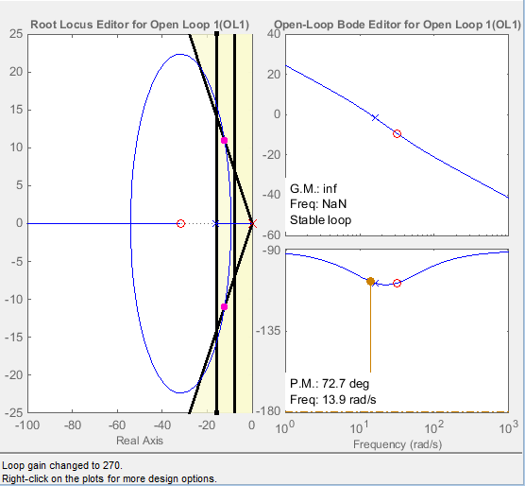

The zero was at -31.8 and the proportional gain was calculated to be 8.37. These values give the above pole/locus plot. These poles are located at $-12±j10.9$

Thus the designed controller is of the form $G_{c}\left(s\right)=\frac{8.37\left(s+31.8\right)}{s}$

The open loop transfer function for the system becomes

$$G_{F}\left(s\right)=\frac{8.37s+269.88}{s^{2}+16s}$$

Using MATLAB, the closed loop transfer function was calculated as,

$$TF\left(s\right)=\frac{8.37s+269.88}{s^{2}+24.37s+269.88}$$

The resulting Step response and pole/zero map from MATLAB are displayed below.

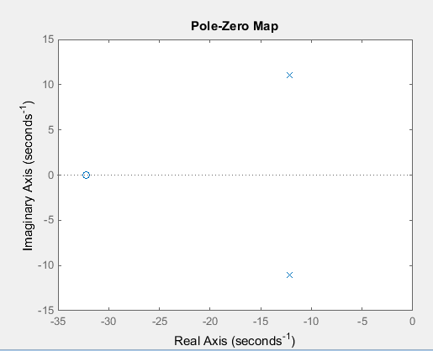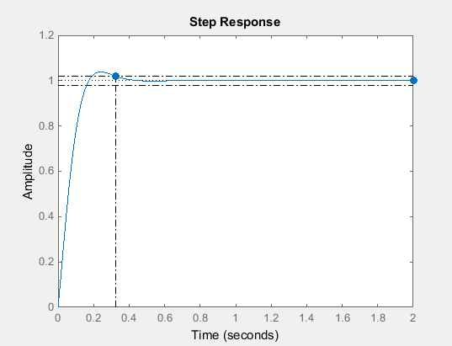

From MATLAB:

$$K_{p}=8.37$$

$${ K}_{i}=\frac{Kp}{Ti}=269.88$$

$$T_{i}=0.031$$

$$ζ=0.742$$

$$ω_{d}=11rad/s$$

$$ω_{n}=16.4rad/s$$

$$e\left(∞\right)=\frac{16T_{i}}{K_{p}}=0.059$$

$$\%OS=3.1\%$$

$$T_{s}=0.325s$$

As can be seen, all of the performance criteria have been met with acceptable accuracy. The final system is shown in the following diagram.

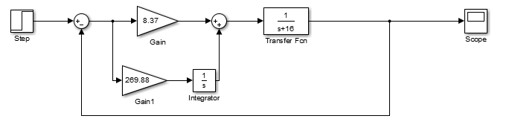

A PI controller adds an extra s term to the denominator which significantly improves steady state error for a step response. This is as it changes any finite value of error to 0 error as the position constant becomes infinite, the error tends towards zero.

# Conclusion

It is clear that this practical has been a success in the fact that the main problem posed at the beginning has been adequately solved but the design of a PI controller. In the process of solving this, the other objective of this task was also met, that is developing understanding for PID controllers and practicing knowledge of control systems to solve problems. Overall this practical has been a success in every aspect with the ultimate goal of developing fundamental engineering skills.